What is Redgate SQL doc?

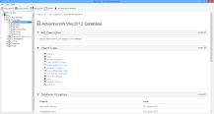

Redgate SQL Doc is a simple tool for describing and generating documentation of SQL Server automatically.

It eliminates the tedious and time-consuming manual documentation tasks and enables you to satisfy audit requirements by keeping complete documentation.

[Database Documentation Generator For SQL Server](https://www.red-gate.com/products/sql-doc/)

[](https://www.red-gate.com/products/sql-doc/)

[Redgate](https://www.red-gate.com/products/sql-doc/)

[https://www.red-gate.com › products › sql-doc](https://www.red-gate.com/products/sql-doc/)

Document your **SQL** Server databases with a few clicks, with **SQL Doc** from **Redgate** Software. Try it free for 14 days.